**Electronics I**

**Mid Term Exam**

**Date: 7th September 2015 Time: 90 Minutes Max Marks. 25**

**Notes: Start every solution on fresh page.**

**Highlight your answers by inboxing or underlining them.**

**Assumptions made should be written clearly.**

**1:** Find the power absorbed by each active and passive element of the circuit given in figure 1. **[5]**

**2:** Using KCL, find the power absorbed by 2Ω resistor in figure 2. **[5]**

**3:** In Figure 3, Vs = 12 V before time t = 0s and it changes to 24 volts at t = 0s. At t = 10s, switch is closed. Find the value of voltage across capacitor as function of time for

1. t < 0s **[1]**
2. 0<= t <=10s  **[2]**
3. T > 10s.  **[2]**

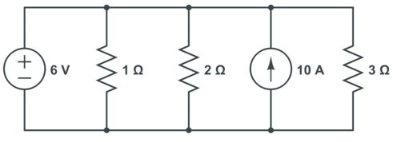 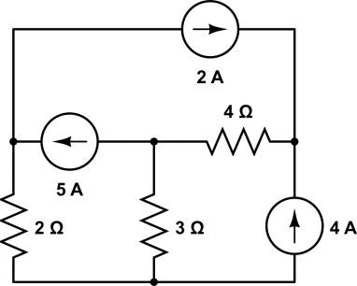 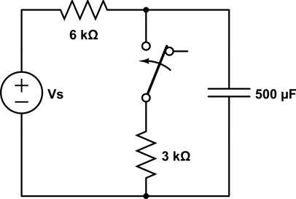

**Figure 1 Figure 2 Figure 3**

**4:** In Figure 4, the switch has remained in shown position for a long time. At t =0s, the switch is moved to new position as mentioned by the arrow. Find the value of Voltage across the capacitor as a function of time. **[5]**

**5:** In Figure 5, If Ve = 120∟10° V, Z1 = 60∟-30° Ω and Z2 = 40∟45° Ω. Calculate the followings

1. Total Apparent Power in Z1 and Z2  **[2]**
2. Total Real Power **[1]**
3. Total Reactive Power  **[1]**
4. Power factor  **[1]**

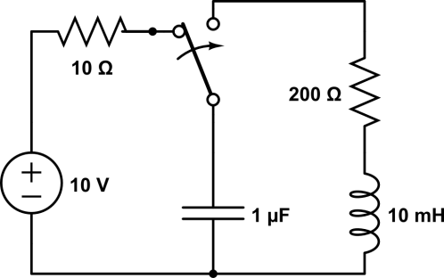 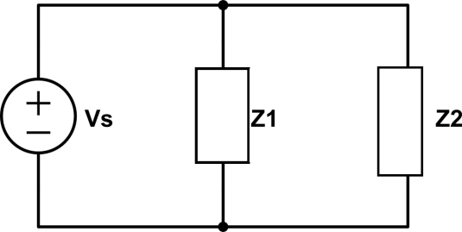

**Figure 4 Figure 5**